**ME3180**

**FEM & CFD Theory**

**Assignment 1**

**ME21BTECH11001**

**Abhishek Ghosh**

**Question 1**

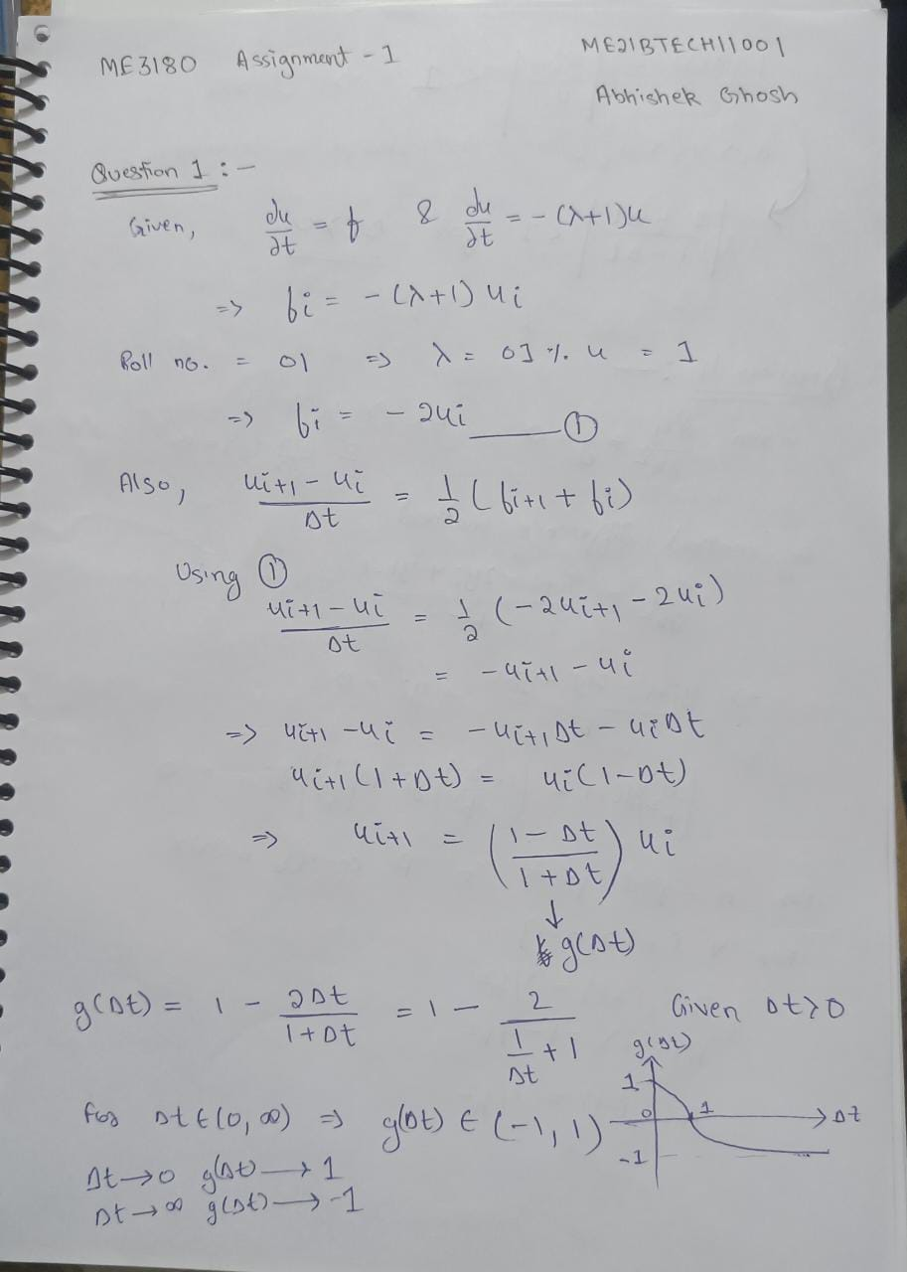

**Question 2**

Case = roll%3 +1

Roll=01

-> case = 1+1= b)

% ME21BTECH11001 Abhishek Ghosh

% ME3180 Assignment 1

% Question 2

clc

clear all

E = 1;

b = 1;

f = 0;

L = 1;

h0 = 0;

h1 = 1;

n=101;

h=(h1-h0)/(n-1);

A = zeros(n,n);

B = zeros(n,1);

B(1)=0;

B(n)=0.01;

A(1,1)=1;

A(n,n)=1;

A(n,n-1)=-1;

x=(h0:h:h1)';

sol = zeros(n,1);

c1 = -0.01/log(2) + 0.5;

c2 = c1*log(2);

c3 = 0.5;

c4 = 0.01 - 0.5*log(2);

sol(1) = c1*log(0.5) + c1*log(2);

% Central Difference

for i=2:n-1

if(x(i)<=L/2)

A(i,i+1)=1/(2*h) +(x(i)+0.5)/h^2;

A(i,i)=-2*(x(i)+0.5)/h^2;

A(i,i-1)=(x(i)+0.5)/h^2 -1/(2*h);

sol(i)=c1*log(x(i)+0.5) + c1*log(2);

else

A(i,i+1)=-1/(2*h)+(1.5-x(i))/h^2;

A(i,i)=-2*(1.5-x(i))/h^2;

A(i,i-1)=1/(2*h)+(1.5-x(i))/h^2;;

sol(i)=0.5*log(1.5-x(i)) + 0.01 -0.5*log(2);

end

end

sol(n)=0.5*log(1.5-x(n))+0.01 - 0.5*log(2);

y = A\B;

plot(x,y,color='r')

hold on

plot(x, sol,Color='b');

[*Published with MATLAB® R2023a*](https://www.mathworks.com/products/matlab/)

**Question 3**

Case = roll%5

Roll = 1

-> case = lambda =1;

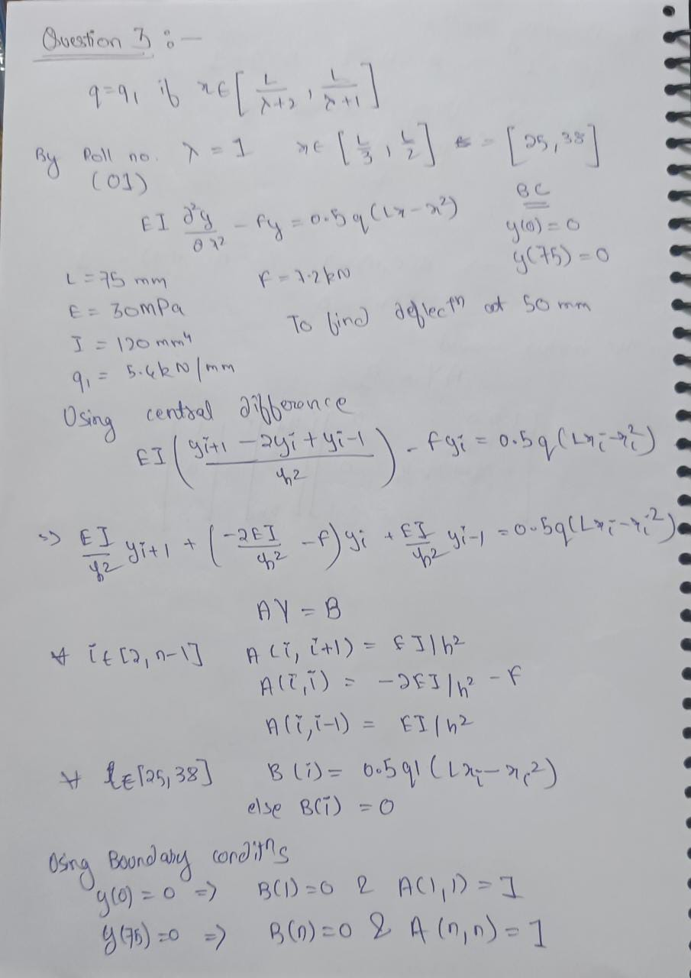

% ME21BTECH11001 Abhishek Ghosh

% ME3180 Assignment 1

% Question 3

% Initial Conditions

E = 30;

I = 120;

q1 = 5400;

F = 7200;

L = 75;

EI = E*I;

a = 0;

b = L;

n = 1000;

h = (b-a)/(n-1);

x = (a:h:b)';

B = zeros(n,1);

A = zeros(n,n);

% Boundary Conditions

B(1)=0;

B(n)=0;

A(1,1)=1;

A(n,n)=1;

% Roll No = 01;

lambda = 1;

lhl = int32(L/((lambda+2)*h));

rhl = int32(L/((lambda+1)*h));

% Central Difference

for i=2:n-1

A(i,i+1) = EI/h^2;

A(i,i) = (-2*EI/h^2 - F);

A(i,i-1) = EI/h^2;

end

for i=lhl:rhl

B(i)=0.5*q1*(L*x(i)-x(i)^2);

end

y=A\B;

k = int32(50/h);

% deflection at l=50mm

y(k)

plot(x,y);

ans =

-6.2018e-06

[*Published with MATLAB® R2023a*](https://www.mathworks.com/products/matlab/)

Deflection at 50mm = 6.2018 X 10-6 mm.

**Question 4**

% ME21BTECH11001 Abhishek Ghosh

% ME3180 Assignment 1

% Question 4

clc

clear all

n = 100;

length = 1;

h = length/(n-1);

x = (0:h:length)';

A = zeros(n,n);

B = zeros(n,1);

sol(1)=cos(0)+tan(1)*sin(0);

% Central Difference

for i=2 : n-1

sol(i)=cos(x(i))+tan(1)*sin(x(i));

A(i,i+1) = 1/(h^2);

A(i,i-1) = 1/(h^2);

A(i,i) = 1-2/h^2;

end

%Boundary Conditions:-

A(1,1) = 1;

A(n,n) = 1;

A(n,n-1) = -1;

B(1) = 1;

sol(n)=cos(1)+tan(1)*sin(1);

Y = A\B;

% plot of x vs actual solution

plot(x,sol,color='r')

hold on

% plot of x and solution via Finite difference method

plot(x, Y,Color='b')

title("Finite Difference for d2y/dx2 = -y")

xlabel("X")

ylabel("Y")

[*Published with MATLAB® R2023a*](https://www.mathworks.com/products/matlab/)

As we increase the number of grid points the Finite Difference solution approaches the real solution -> converging

